**Robotics I – Project 2 Fall 2018**

**Building the graphical interface for our rover simulation**

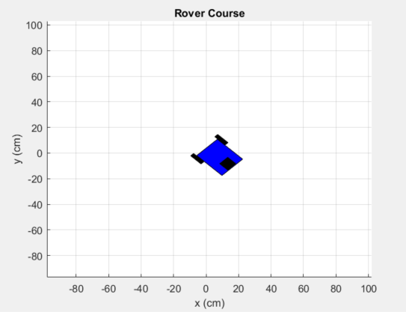

**Project Assignment: Develop the graphics (drawing) portion of the rover simulation in Matlab. Use the provided code files as a base, modifying them based on the following:**

1. **Code the body of the function which rotates a 2xN matrix of points corresponding to the relevant drawing points on the vehicle.**
2. **Add graphical vertices and faces for the tires of the ground rover.**
3. **Demonstrate a functional simulation using the Top_Level.m script provided.**

**Notes:**

**Search the “drawCar.m” file for the text “TODO.” This will show you where you are to add the code for the modifications.**